A brash biotech VC speaks out on headwinds in the industry, and what the future may hold
Founder of Omega Funds acknowledges there ‘should be some anxiety’
Adobe

By Allison DeAngelis
April 7, 2025
Biotech Startups and Venture Capital Reporter
Omega Funds founder and managing director Otello Stampacchia isn’t afraid to tell it like he sees it.
Back in 2022, as the biotech industry’s boom was plateauing, the brash venture capitalist told executives at the biotechs he had invested in that they would be “insane” to pursue an initial public offering, or IPO. In a conversation with STAT late last month, he took a dim view of the current roster of biotech VCs and argued investor attitudes have seeded “the destruction of the industry.”
His comments may strike some as impudent or cheeky, but his attitudes toward biotech investing have proven successful. The Italian investor founded Omega Funds in 2003 after stints at various health care investing firms. Omega Funds has now invested in more than 150 companies that have produced 51 products.
Even Stampacchia himself has been surprised at just how well the fund has performed over the last three years, which have been arduous for the industry: Since early 2022, eight of the firm’s portfolio companies have gone public on the stock market, and 14 have been acquired, earning his investors payouts. (Stampacchia was so surprised by the figures that he asked his team to check them three times.)
STAT spoke to Stampacchia about how his firm has navigated biotech’s extended era of discontent, and what he expects from the years to come.
In particular, he anticipates that fewer biotechs will get started in the U.S. “There should be some anxiety,” he said. “There’s going to be less adventurous basic research.”
This transcript of the interview has been edited for length and clarity.
When you’re looking at this type of uncertain economic environment, how does Omega change or not change its decision-making compared to, say, the heyday of 2019?
Actually, the decision-making has not changed… We have always been a multi-stage investment firm. We’ve always been product-focused.
You say 2019, but I think the heyday lasted a little bit longer than that, in my opinion. But what we saw in those days was that what is a very important role firms like us end up playing, ended up being usurped.… Governance and the discipline on spending and program prioritization got out of whack…. There’s statistics being published now by Jefferies and a bunch of other people that the clinical success rate in early-stage trials has gone down dramatically in the last five years. Why the heck do we think that is? Because all the discipline, all the program prioritization, all the governance, has gone out of the window.
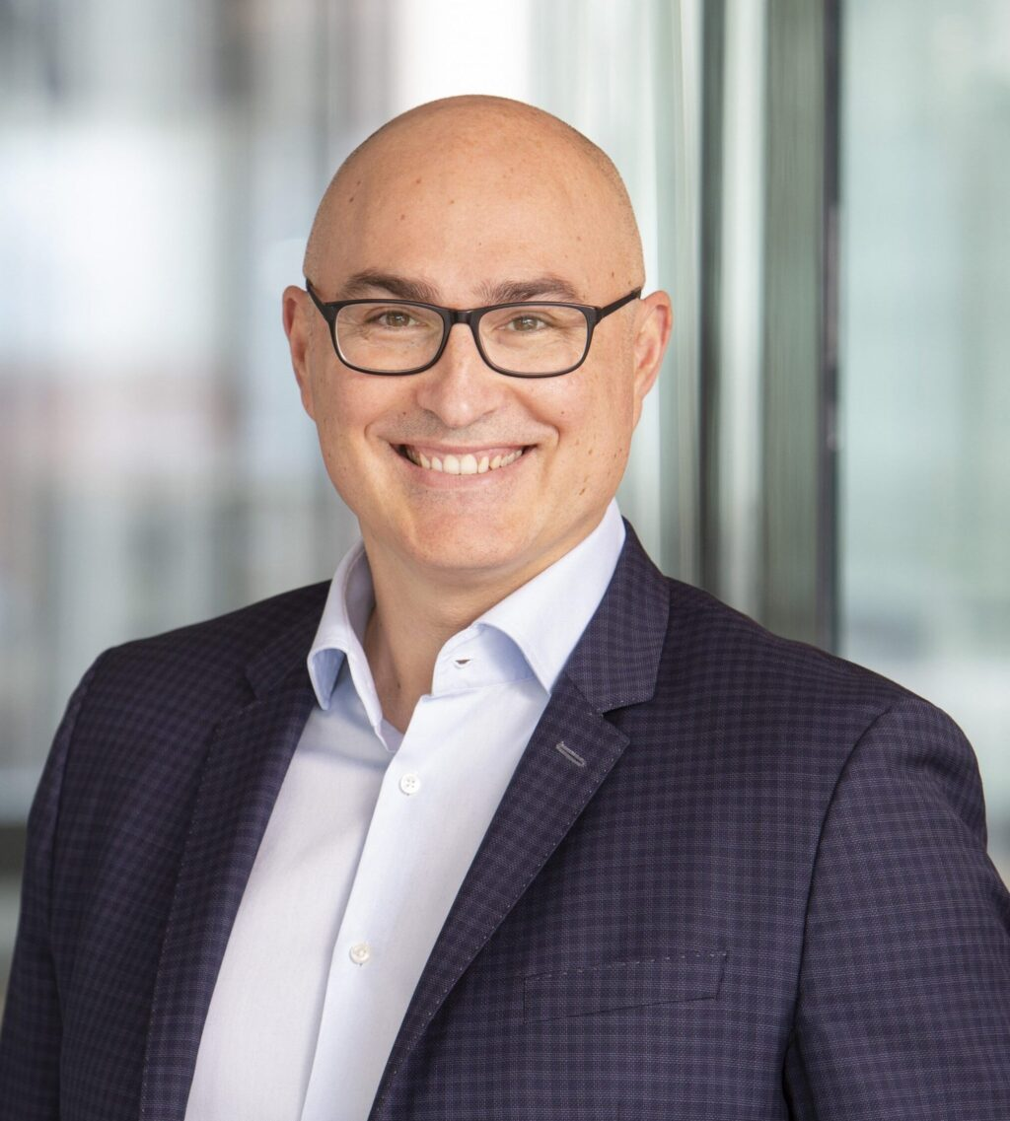Otello StampacchiaCourtesy Omega Funds
The tactics [at Omega] have changed a bit, because we are now back into filling that role of imposing a certain level of governance, which, I have to tell you, not every management team loves. They all want to say, “oh, let me go out and raise $200 million,” which I don’t know if it’s feasible right now, to be honest. It might not have been the right idea, even when it was feasible.
On raising $200 million, you just said you’re not sure that’s feasible anymore. Omega was just involved in launching Windward Bio in January with that amount of money. Where’s the disconnect? Has something changed since January?
Every situation is context dependent, right? [This is an] extremely experienced team, and I can tell you, I’ve been on a few boards over my career, and our first official in-person board meeting was a few months back. I came out saying, “holy s—,” right? The board [of director’s slide] deck was astounding, succinct, extremely logical, to the point. “Here’s the runway, here’s what’s happening with the clinic. Here’s what we need to worry about, here’s the competition.”
We get extremely involved and granular on clinical operations…. This is, by the way, one of our superpowers, because you can’t really do program prioritization without appreciating the challenges of [clinical trial operations]. Sorry to be arrogant, but none of our peers gives a s—. For a business that lives and dies on enrolling patients into trials, we are consistently the only VC on all the boards that we’re in that asks about [clinical operations].
Do you think that comes back to a mindset or an assumption from years ago that you would be able to sell the company to a pharma buyer before you really got deep into the clinical process?
I think there’s something to that. I also think a lot of our peers, a lot of my peers, get very excited about the science, but they don’t want to get into the weeds when it comes to how you take the science and translate it into an actual product which has to go through the clinic.

The biotech scorecard for the second quarter: 24 stock-moving events to watch
Back in early 2022, you told your portfolio companies that they would be stupid to consider IPOs. But you’ve had seven or eight IPOs since that time. What are you telling the companies you’ve invested in now?
Generally, we try to give the same advice. Now, there are two caveats: Not everybody listens. And the second is, well, some companies actually do need that kind of quantum of capital, which is very hard to find in private markets.… Sometimes we say, “Well, you shouldn’t probably be public now, but it’s probably the only way you can raise $200 million or $300 million.”… If you can stay private and deliver on clinical data, stay private.
Again, not everybody listens, because it goes back to the governance, right? There’s a bit of an issue sometimes because management teams think that by being public, they can get rid of those pesky VCs on their board…. You cannot have just your cake and eat it — if you want to have investors like us, well, we are opinionated. Doesn’t mean that we’re right, but we need to have a fact-based discussion on why you’re going to do something different than our opinion.
What’s your outlook today on the biotech industry and investing?
So, at the macro level, there are a lot of reasons to be concerned…. It’s like a barbell. The later-stage stuff, I think, is getting screwed, and the super early-stage research is getting screwed.
On an even more macro level, the general instability is not good for business, because it affects — I’m being superficial, but this is how a lot of investors think — the instability affects the outlook on interest rates. The potential for huge, widespread tariffs affects the outlook on inflation, and therefore interest rates…. At the public biotech level, very high interest rates for a prolonged period of time is bad. And then you add on that the potentially untargeted and disruptive cuts on personnel within very important industry regulators. I personally believe, in the immediate short term, that affects mostly large pharma trials. But eventually comes back and bites at our industry, as well. And the opposite end — which is the barbell we talked about — is the amazing uncertainty that is now permeating early research, and I think it’s going to start to affect company creation, which ultimately feeds a lot of what we do.
What do you think the U.S. biotech system will end up looking like? Are we talking about a drop in these Series A rounds we’ve been rising? Are there some things we end up ceding to China’s competitive advantage? I think there’s a lot of anxiety among U.S. biotechs.
There should be some anxiety…. So, there’s stock and there’s flow. The flow is what gets created every year in terms of new companies, and what gets financing, and what grows into a proper size company…. That flow is going to be affected by these NIH issues, because I think you’re going to see less company creation in the short to medium term, right? Because there’s going to be less adventurous basic research… The proliferation of Chinese molecules is also going to affect the flow.
Now, that’s potentially a very concerning message. However, I would like to temper it by saying that the stock is overloaded. The current number of companies in biotech… It’s over-bloated because there’s too many public companies who are potentially not going to be able to deliver clinical molecules, they don’t have a top tier C-suite, and there’s too many companies who have been kept… you know, the expression that comes to mind is kicking the can down the road.
Now, eventually this will find an equilibrium…. What I’m saying I think is going to happen is not going to be pleasant. There’s going to be a massive tendency to say, “Oh, wow, this market is terrible.” Which is not entirely wrong, but I believe we are living proof as a firm that a terrible market doesn’t mean not being able to deliver on clinical products, on exits, on distributions to your investors and so on.
We need to be very careful about this because, to say, “well, I wish we were back in 2019… ” When [public market investors] say that, I get actually quite upset, because it is not possible to believe that that was a good time for the industry. We were seeding the destruction of the industry with the permissive behaviors that were allowed in those years. Going back to those years is not healthy. This is a business of selectivity: selectivity of the molecules, selectivity of patients that we enroll and try to treat, selectivity and skill and capabilities of management teams.

